**George Philipp Telemann and his legacy on the music of the German-speaking lands 1700-1750**

George Philipp Telemann was born in Magdeburg on the 14th March 1681 and was raised in a family with strong ties to the Lutheran Church. From his early childhood, Telemann showed promising talent and had mastered the violin, flute, guitar, and keyboard. By the age of 12, he had nearly finished composing an opera on the text by Postel called *Sigismunudus* against the wishes of his parents who disapproved of music. This resistance only further ignited his ambitions to pursue his musical studies by transcribing and modelling his works off Agostino Steffani, Johann Rosenmuller, Arcangelo Corelli and Antonio Caldara.

After being admitted to Leipzig University in 1701, Telemann enrolled in law – aligning with his mother’s wishes. On route to Leipzig, Telemann stopped by Halle to make acquaintance to Handel which was by no coincidence – he ultimately had no intention of abandoning his interest in music. Although it was implied that he would study languages and sciences at first, his founding of the Collegium Musicum within the first year sparked the beginning of his musical career. During his time in the Collegium Musicum society, he performed numerous public concerts (in which Bach later became the director), composed operas for the Leipzig Theatre, held the position as musical director of the Leipzig Opera in 1703 and ended up as the organist of the Neue Kirche in 1704.

After several annoying complaints by Kuhnau – who saw his role being jeopardised due to Telemann involving several students in several public performances, Telemann sought to make something more of his life. Luckily, the Court Erdmann II of Fromnitz at Soarou had invited Telemann to become the Kapellmeister of his court in which Telemann gracefully accepted in 1705. A great period of his time was spent networking with Wolfgang Caspar Printz and Erdmann Neumeister, where he was able to experiment with French, Italian, and the local Polish folk music (more described later). But due to the threat of the invasion by the Swedish Army, Telemann’s contract was abruptly cut short as the Court was disbanded.

His next appointment between 1706 and 1708 was at Eisenach as the Konzertmeister with Pantaleon Hebenstreit as the orchestra leader. Although Telemann had entered a period of relative stability and mainly composed church cantatas, the end of his short-lived marriage ended with the passing away of his wife in 1711. With a need to escape and change scenery, Telemann journeyed to Frankfurt to hold both the post as Director of Municipal Music and Kapellmeister of the Barfußerkirche and as the director of the musical society Frauenstein (which held weekly public concerts). With a clean slate and a fresh start, Telemann begun to produce five-year-long cycles of church cantatas, music for civic ceremonies, oratorios and several orchestral and chamber music, but never produced any works of opera – although he still wrote works for the Leipzig Opera. Eventually, after recognition, the Prince of Bayreuth granted him the role of Kapellmeister and eventually settled down after marrying again.

Whilst visiting Eisenach in 1716, Telemann, due to his status as a visiting Kapellmeister served the court as a diplomatic correspondent. This increasing stature only sped up the following year when he was invited to become Kapellmeister of all the courts of the Duke Ernst of Gotha. By no coincidence, a trip to Dresden for the celebration of marriage between Prince Elector Fredrich August II and Archduchess Maria Josephia of Austria in 1719 led to the reunification with Handel. During this time, Telemann was granted the chance to listen to operas by Lotti and various violin concertos dedicated to Pisendel in which Telemann had become acquainted with through J.S. Bach in 1711. Telemann’s Solo Fantasies for Violin without Bass (1735) was one of few works dedicated to Pisendel.

After a few years, Telemann was invited to succeed Joachim Gerstenbuttel - the distinguished post as Kantor of the Hamburg Johanneum. This granted him the prestigious role that could provide him with the necessities to reach his limits – a requirement to compose two cantatas weekly, a passion annually and to provide compositions for civil ceremonies when needed. Despite these heavy responsibilities, he still managed to fulfil the additional commissions he was still receiving.,

The chances to also be actively involved in the Hamburg Opera, specifically his opera *Der geduldige Socrates* which had earlier been performed - was strongly opposed amongst the city fathers. This reaction caused Telemann to threaten the option of resigning – he was chosen over Bach and many other candidates for the position as Kantor of the Leipzig Thomaskirche. Whilst the Hamburg City Council did not let him go, they inevitably increased his salary and their objections to his association with Hamburg Opera were dropped[1]. In the end, Telemann was appointed the music director of the Hamburg Opera, holding the post until the closure in 1738. During this time, he composed various works where only some excerpts published in the *Der gertreue Musimeister* have survived.

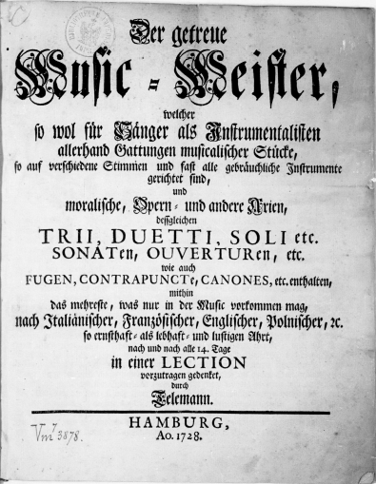The *Der getreuer Musikmeister* (Fig. 1.)[2] was founded by Telemann and Gorner in 1728 and translates to “*The Faithful Music Master”*. It was in the style of a German music periodical lesson to learn music through lections and it was performed every fortnight in the format of a four-page reading/lesion. The lection was also an ingenious method of giving exposure and circulating his new compositions where much of it was by Telemann himself, but composers such as Keiser, Pezold, Gorner, Zelenka, Ritter, and Stoltzer were also represented. Sadly, only 25 of these periodicals survived and we are unsure how long the periodical appeared for. The first lection, first page is the introduction to Sonata form on the Flauto (Flute) (Fig 2.) with a noticeable Italian style. It appears to not vary widely from any of Corelli’s sonatas (especially Telemann’s *Corellisirende Sonaten* (Fig. 3) which resemble Correli’s manner significantly[3]) who were amongst one of Telemann’s early influences. [4]

Fig. 1 Collection of various compositions by Telemann and other composers, published by Telemann in 25 "Lections" between 1728-1729. These were intended as a sort of home music lesson and were more aimed at the amateur market than the works in *Essercizii musici*. *Description from IMSLP*

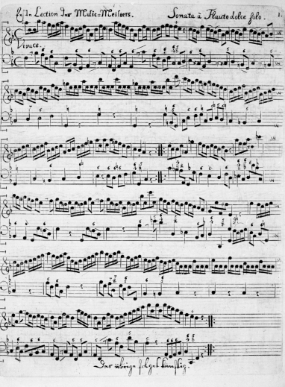

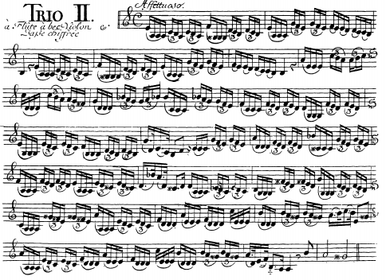

Fig. 2 Lection 1, Page 1 in Sonata form for Flute and continuo bass

Fig. 3 Trio 2 from Telemann’s Six Trio Sonatas

The *Corellisirende Sonaten* better known as *The Six Trio Sonatas* contain a remarkable number of elements, following closely to the Italianate style; Corelli mannered fugues in Trio 1 and 5, Polish folk music influences in Trio 3 and 4 and French style dance movements in Trio 2 and 6. Many sections in the violin part feature styles inspired by *Vivaldi’s 12 Violin Sonatas* can be seen using simple bariolage[5]. (Fig 3. And Fig 4.).

Fig. 4 Sonata 2 from Vivaldi’s 12 Violin Sonatas

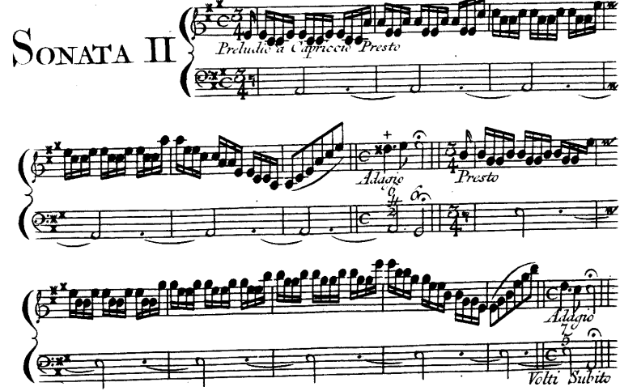

Telemann’s friendship with Handel continued after their reunion in Dresden. Both parties corresponded over the course of several occasions and in 1750, Handel sent him “a crate of flowers, which experts assure me are very choice and of admirable rarity” to Telemann from London. Handel also continued to show support by appearing on the list of subscribers to the *Musique de Table*, which was a collection of Telemann’s most ambitious compositions[6] through three instalments during 1733. The significance is linked to Germany’s first prints made of pewter as opposed to copper (first employed in London by Walsh and Hare in 1710[7]) in which Telemann himself supervised from the preparation of the engraved plates until the printing.

To his fellow peers, Telemann was one of the greatest living composers. Prolific as he was, Telemann provided both sacred and secular works totalling up to more than 3000 compositions all whilst maintaining an active role in public performances. Music that was previously reserved only for the court and aristocrats was brought forth to the public through his public concerts. Equally important were also his publishing techniques, introducing the pewter method of engraving and pursued exclusive rights to his works – regarding music as intellectual property of the composer.

Bibliography:

Petzoldt, Richard. Georg Philipp Telemann. New York: Oxford University Press, 1974.

Zohn, Steven David. Music for a Mixed Taste: Style, Genre, and Meaning in Telemanns Instrumental Works. Oxford: Oxford Univ. Press, 2015.

Telemann, Gerog Philipp. Autobiographie: 1718, 1729, 1739 (English Edition).

Mattheson, Johann, and Max Schneider. Grundlage Einer Ehrenpforte. Graz/Austria: Akademische Druck- U. Verlagsanstalt, 1994. Translated to English

"Georg Philipp Telemann: A Detailed Biography." The Gottfried Silbermann Legacy. <http://www.baroquemusic.org/biotelemann.html>.

Telemann: 6 Violin Sonatas. <https://www.brilliantclassics.com/articles/t/telemann-6-violin-sonatas/>.

Bergmann, Walter G. "Georg Philipp Telemann." Encyclopædia Britannica. March 08, 2018. <https://www.britannica.com/biography/Georg-Philipp-Telemann>.

Borgir, Tharald. "The Performance of the Basso Continuo in Italian Baroque Music." Performance Practice Review.

IMSLP/Petrucci Music Library: Free Public Domain Sheet Music. All manuscript, sources and sheet music were obtained from here.

1. "Georg Philipp Telemann: A Detailed Biography." The Gottfried Silbermann Legacy. http://www.baroquemusic.org/biotelemann.html.
2. "Der Getreue Music-Meister (Telemann, Georg Philipp)." - IMSLP/Petrucci Music Library. http://imslp.org/wiki/Der_getreue_Music-Meister_(Telemann,_Georg_Philipp)
3. Telemann: 6 Violin Sonatas. https://www.brilliantclassics.com/articles/t/telemann-6-violin-sonatas/.
4. Borgir, Tharald. "The Performance of the Basso Continuo in Italian Baroque Music." Performance Practice Review.
5. Bariolage – a violin style and technique used to represent multiple stops by breaking them up into separate distinct notes. Relatable examples include: Bach’s E Major Partita, Vivaldi’s A Minor Concert and the Theme and Variations on Corelli by Kreisler
6. Kraemer, Nicholas - conductor. PROGRAM NOTES TELEMANN for the Overture in B Minor, TWV 55:h1.
7. "John Walsh." - IMSLP/Petrucci Music Library: Free Public Domain Sheet Music. http://imslp.org/wiki/John_Walsh.